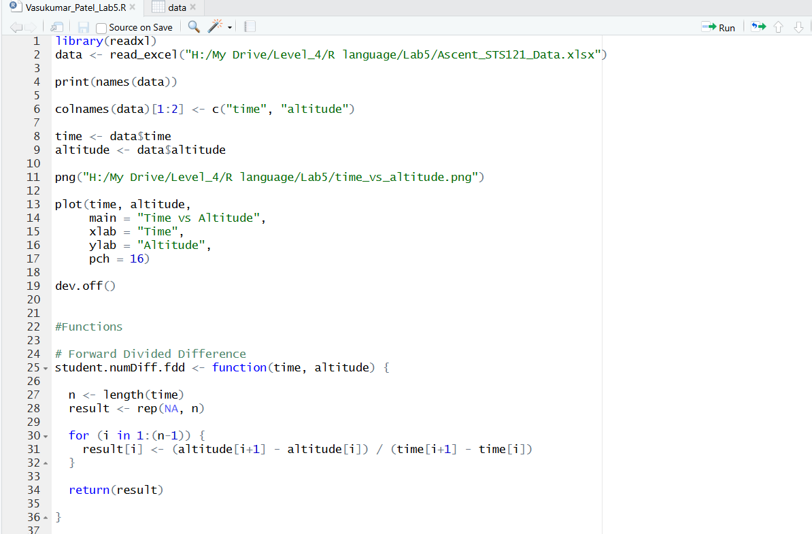

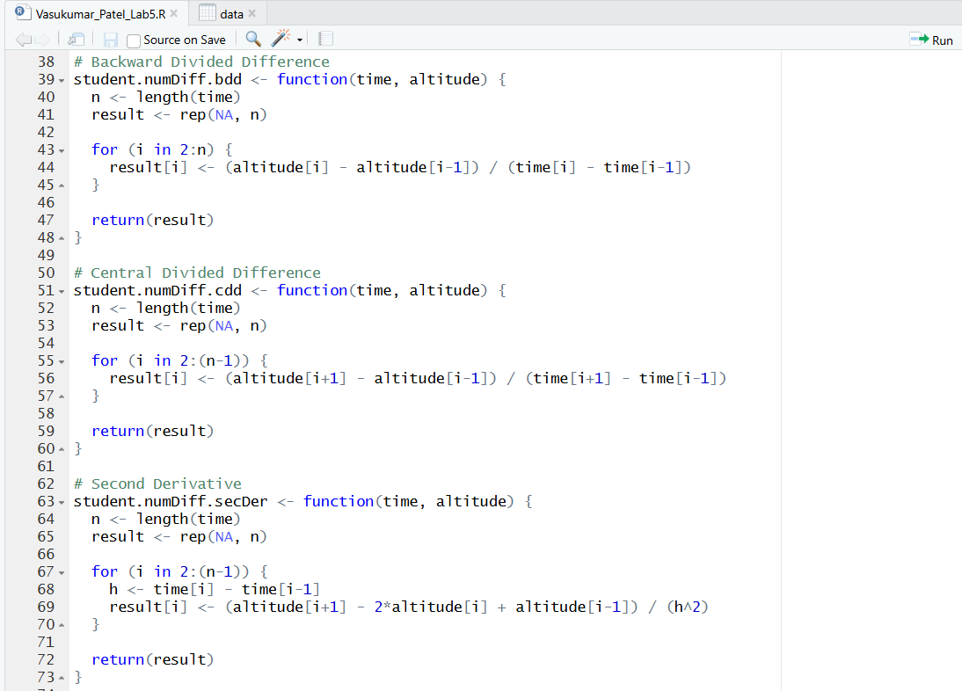
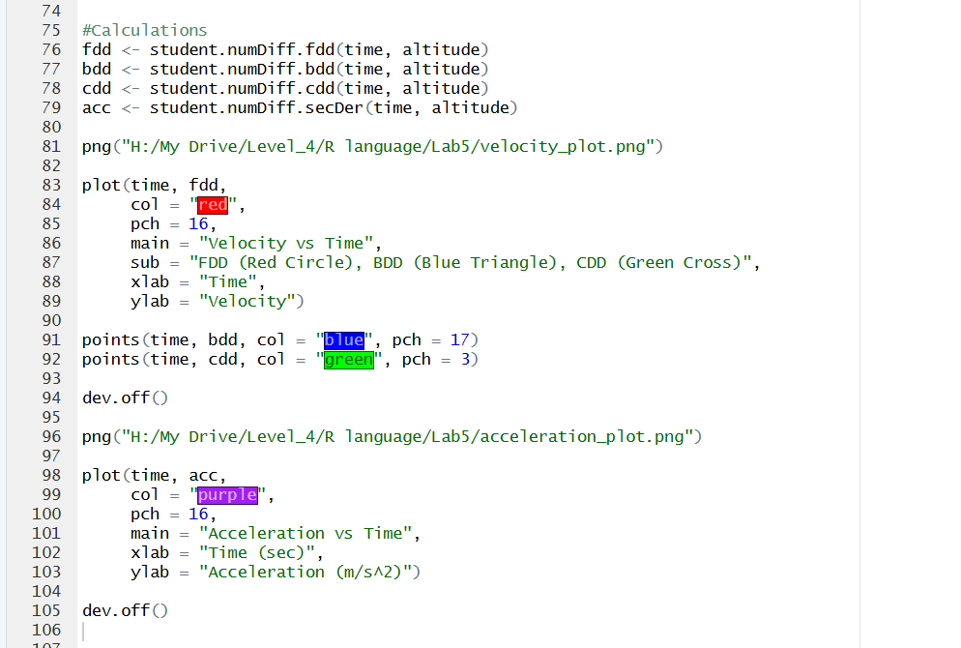

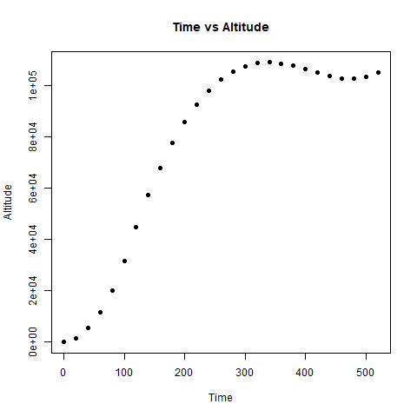
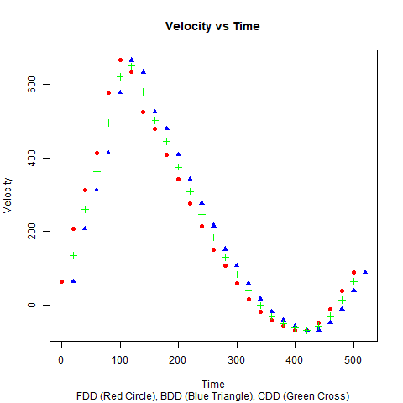
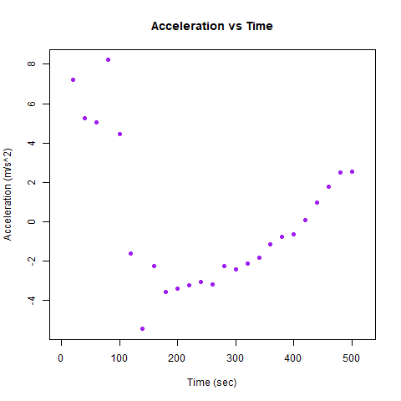
- Why is there only 1 data point at 0 sec?
- At 0 seconds, there is only one data point because we cannot look at a value before 0.
The backward and central methods need a previous value, but it does not exist.
Only the forward method works, so only one point appears.

- Why is there only 1 data point at 520 sec?
- At 520 seconds, there is only one data point because we cannot look at a value after 520.
The forward and central methods need a next value, but it does not exist.
Only the backward method works, so only one point appears.

